PREVENTATIVE MAINTENANCE
&
REBAR SPALLING DAMAGE REPAIR

NOVA TECH FOUNDATION REPAIR, LLC
979-203-6142
office@novatechfr.com
Mailing: 1576 Bell Oaks, Bellville, TX 77418
www.novatechfoundationrepair.com

Concrete Slab-on-Grade Foundation Maintenance

- Do NOT focus on watering your foundation. Focus on watering your vegetation (lawns, trees, shrubs, etc.). Your vegetation and/or landscaping is a good “barometer” of when & how much to water.
- A drip system can be installed around your foundation with emitters on your plants. Drip systems can be controlled better than soaker hoses. The drip system and/or any watering system should be no closer than 18” from the house. Please keep in mind that the drip system should not be the only watering being performed. The entire yard especially within 10’-15’ of the structure needs to be maintained.
- Gutter systems with extensions on the downspouts should be installed to control rainwater flow. We like to see it take the water at least 10’ away from the structure. Make sure to keep the gutter system clean.
- Proper drainage should be in affect around the structure as to allow the flow of water to move away. Sometimes re-grading of the land and creating a swale to help move water runoff away from the structure is necessary. Please note that a French drain is a drainage system of last resort & should not be installed within 10’ to 15’ of a structure.
- There should be a positive slope in the soil adjacent to the foundation. We would like to see the minimum standard of 5% slope (6” of fall in 10’).
- Make sure the soil from flowerbeds and such is not above the foundation line. According to minimum code, it should be 6” below the foundation line. It can either clog the weep holes or allow outside water to gain access into the structure.
- Water should not be allowed to pond around the structure. When water ponds in expansive soils, it can cause the soil to lose its load-bearing capacity. This will then allow the structure to sink in that area.
- Keep all concrete flatwork joints sealed with concrete/driveway caulk when redwood or merch wood has rotted out or when separation has occurred.
- If the air conditioning auxiliary or secondary line is dripping outside, it could be a sign that there may be a clogged primary line or drip pan. Over time that dripping could cause the soils to swell or lose load bearing capacity to support the structure. The line can, also, be extended to drip away from the structure.
- Do not plant trees within the same distance as their mature height. (i.e. if a tree is 40’ tall at maturity it should be planted at least 40’ away from the structure)

*Even with all the preventative maintenance performed, some movement can still potentially occur. Mother nature & God still have total control. Homeowners just need to do everything they can to minimize the risk of movement.
Pier & Beam or Block & Base Foundation Maintenance

- These foundations should NEVER have any water flowing or ponding under or next to the structure. Flowing water can create erosion. Water ponding can cause the soil to lose load-bearing capacity. This will then allow the structure to sink in that area.
- Water your lawn, trees, & flower beds NOT your foundation. The vegetation and/or landscaping is a good “barometer” of when & how much to water.
- There should be a positive slope in the soil adjacent to the foundation. We would like to see the minimum standard of 5% slope (6” of fall in 10’). The soil adjacent to the structure should be lower than the soil under the structure. If water were to gain access under the structure, it needs to be able to get out. If it is lower than the outside, it essentially has a pond under the structure.
- Gutter systems should be installed all around the house with the extensions on the downspouts extending a minimum of 10’ from the house. Make sure to keep the gutter system clean.
- Proper drainage should be in place around the structure as to allow the flow of water to move away. Sometimes re-grading of the land and creating a swale to help move water runoff away from the structure is necessary. Please note that a French drain is a drainage system of last resort & should not be installed within 10’ to 15’ of a structure. If you have a basement, then a French drain system should be installed adjacent to the structure at the basement floor level.
- The crawlspace should not be exposed to the elements, so some type of solid skirting should be installed with enough ventilation (lattice is not considered solid skirting).
- Vents should be installed directly across from one another as to allow cross-ventilation. IF there are no vents in the skirting, the air cannot circulate causing mold, fungi, & bacteria growth to build up. The formula is 1 sq. ft. of ventilation per 150 sq. ft. crawlspace.
- Keep all concrete flatwork joints sealed with concrete/driveway caulk when redwood or merch wood has rotted out or when separation has occurred.
- If the air conditioning auxiliary or secondary line is dripping outside, it could be a sign that there may be a clogged primary or drip pan. Over time, that dripping could cause the soils to swell or lose load-bearing capacity to support the structure. The line can, also, be extended to drip away from the structure.

*Even with all the preventative maintenance done, some movement can still potentially occur. Mother nature & God still have total control. Homeowners just need to do everything we can to minimize the risk of movement.
Basement or Walk-out Basement Foundation Maintenance

- Do NOT focus on watering your foundation. Focus on watering your vegetation (lawns, trees, shrubs, etc.). Your vegetation and/or landscaping is a good “barometer” of when & how much to water.
- A drip system can be installed around your foundation with emitters on your plants. Drip systems can be controlled better than soaker hoses. The drip system and/or any watering system should be no closer than 18” from the house. Please keep in mind that the drip system should not be the only watering being performed. The entire yard especially within 15’ of the structure needs to be maintained.
- Gutter systems with extensions on the downspouts should be installed to control rainwater flow. We like to see it take the water at least 10’ away from the structure. Make sure to keep the gutter system clean.
- Proper drainage should be in affect around the structure as to allow the flow of water to move away. Sometimes re-grading of the land and creating a swale to help move water runoff away from the structure is necessary.
- A French drain must be installed around the entire basement area at the basement floor level. The system should be a minimum of 6” with the holes down. The system must stay maintained and functioning.
- A sump pump system should be installed inside the basement area.
- There should be a positive slope in the soil adjacent to the foundation. We would like to see the minimum standard of 5% slope (6” of fall in 10’).
- Make sure the soil from flowerbeds and such is not above the foundation line. According to minimum code, it should be on average 6” below the foundation line. It can either clog the weep holes or allow outside water to gain access into the structure.
- Water should not be allowed to pond around the structure. When water ponds in expansive soils, it can cause the soil to lose its load-bearing capacity. This will then allow the structure to sink in that area.
- Keep all concrete flatwork joints sealed with concrete/driveway caulk when redwood or merch wood has rotted out or when separation has occurred.
- If the air conditioning auxiliary or secondary line is dripping outside, it could be a sign that there may be a clogged primary line or drip pan. Over time that dripping could cause the soils to swell or lose load bearing capacity to support the structure. The line can, also, be extended to drip away from the structure.
- Do not plant trees within the same distance as their mature height. (i.e. if a tree is 40’ tall at maturity it should be planted at least 40’ away from the structure)

*Even with all the preventative maintenance performed, some movement can still potentially occur. Mother nature & God still have total control. Homeowners just need to do everything they can to minimize the risk of movement.

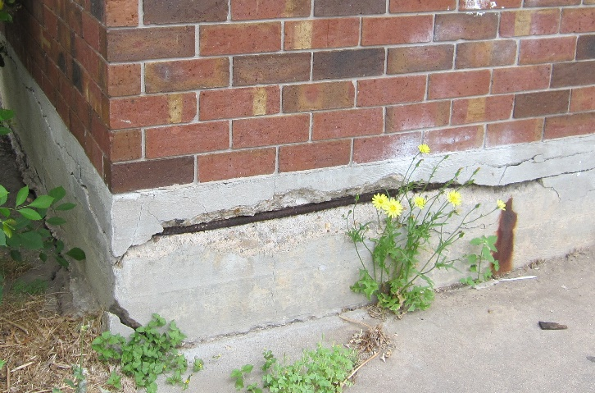
Rebar Spalling Damage Repair
Rebar spalling damage is when the rebar or other structural steel in the concrete is placed to close to the edge and it begins to rust due to moisture. When steel rusts it expands causing the concrete to delaminate or flake off exposing the structural steel. It is pertinent to stop the rest of the steel from rusting. The following steps need to be followed closely as well as product instructions.

- Remove any flaking concrete that has delaminated. You may even have to chip out some of the concrete until you no longer see any rust. If the rusting is extensive & is deep you may need to hire a professional.
- Clean the exposed rebar or steel thoroughly using a wire brush for small areas or an angle grinder for larger areas.
- Using a somewhat stiff paintbrush remove any debris, dirt particulates, & dust from the concrete & rebar or steel.
- Before moving on make sure that the concrete & rebar or steel is thoroughly dry. This may take a couple of days depending on the humidity. Do not allow any debris to get onto the surface areas that will be treated.
- Paint Os-Pho or Loctite Extend Rust Neutralizer onto rebar or steel, make sure to follow directions on the container. Allow to dry completely. Do not allow any debris to get onto the surface areas. Once again, the drying process could take a couple of days depending on the humidity level. If it is not thoroughly dry before starting the next step a chemical reaction could take place, causing more damage to the concrete & rebar.
- Apply a bonding adhesive, such as Quikrete concrete Bonding Adhesive; make sure to follow directions on the container.
- Using a concrete epoxy for small areas or concrete to patch larger areas, fill in & cover the exposed rebar or steel. Try to do it as neat as possible, making the patch flush with the original concrete. Keep a bucket of water & float on hand for smoothing out the concrete.

*These recommendations are solely the opinion of this contractor. It is advisable for the homeowner to obtain a second opinion from a Licensed Professional Engineer.

Pier & Beam or Block & Base Ventilation Recommendations

If your crawl space is not encapsulated, then it must be vented according to the International Residential Code (408.1). Ventilating the crawlspace serves two purposes. 1) it keeps the air circulating (moving) so that it retards the growth of mold, bacteria, fungi, etc. and 2) to vent humidity. Yes, I know we are in Texas and it is humid. However, anytime water or the natural humidity in the crawlspace increases, we want to help the humidity to escape and not become trapped. The following is what is recommend for ventilation:

- The minimum standard for the number of vents that are required is determined by the following formula: 1 square foot of ventilation per 150 square feet of crawl space OR area to be ventilated. Please see the attached worksheet for help in determining your ventilation needs.
- Net Free Ventilation (NFV) - how much ventilation the vent provides. Knowing the NFV of the vent will help determine how many are needed. Different sizes & brands of vents will have different NFV’s.
- All vents should be 4 inches-6 inches above the outside ground level, as to prevent water from getting into the crawlspace through the vents.
- Vents must be directly across (or as close as it can get to being directly across) for cross ventilation.
- Must have a vent within 3 feet of every corner.
- If the above is unattainable, a forced air ventilation system controlled by humidistat will need to be installed AND possibly a dehumidifier.
- The other option is to encapsulate the crawlspace.

*These recommendations are solely the opinion of this contractor. It is advisable for the homeowner to obtain a second opinion from a Licensed Professional Engineer.

